Kent Partnership Filming Guidelines – COVID-19 Annexe
Filming in Public Locations
This Action List has been created in collaboration with Film Officers UK, Creative England, Film London and the London Filming Partnership’s COVID-19 Working Party. It is supplementary to Kent Film Office’s overarching protocols and provides guidelines for production companies and filmmakers that are filming on location in Kent & Medway whilst COVID-19 restrictive measures are in place. It temporarily annexes the Kent Partnership Filming Guidelines and until further notice applies to:
“all location filming and commercial photography projects (including feature films, television, commercials, drama documentaries, music videos, idents, stills shoots, student and short film crews), excluding newsgathering.”
No Action within this list supersedes any other part of the Kent Filming Guidelines.
For further help, advice and access to resources please contact the Kent Film Office by email or call 03000 422000 during office hours.

Purpose of this Action List
The primary purpose of the Actions listed are to ensure that Kent & Medway location filming complies with Government COVID-19 safety guidance and that filming activity does not increase the risk of spreading COVID-19 in the public domain.
Complying with this Action List alone does not constitute permission to film. For permission to film to be granted, Production Companies should complete the Kent Film Office filming permit application process.
This Action List is dynamic in that it will be amended as and when changes in government guidance are published until such a time when the Action List is deemed superfluous and will therefore be removed from the Code of Practice.
This Action List supports and compliments:
- All UK Government guidance with regards to Working Safely During Coronavirus COVID 19
- The BFC COVID 19 Code of Practice June 2020
- The UK Broadcasters TV Production COVID 19 Guidance May 2020
- The APA COVID 19 Guidelines May 2020

This Action List assumes that cast and crew of productions are already utilising the Guides referenced above before scouting the location. The industry Guides above recommend the services of a COVID-19 Health and Safety Officer / Supervisor during pre-production and planning stages of a shoot. The Actions listed below assume that this recommendation has been followed. Kent Film Office may ask which COVID-19 guidance the production is following and ask who the lead COVID-19 contact will be on location on the day of the shoot as part of the filming permissions process.
Contents
1. All Productions Filming in Public Spaces
2. Filming On Street (Non-Road Closure)
3. Filming On Street (with Road Closure)
4. Parking on Street
5. Filming in Parks and Open Spaces
6. Filming in Enclosed / Interior Public Locations
7. Unit Bases in Public Spaces

All cast, crew and contractors of all Productions to comply with the following:
- All Productions Filming in Public Spaces:

  - Enough planning time will be scheduled to allow for additional COVID-19 measures needed on Location and the additional liaison required with the Kent Film Office and residents/businesses.

  - Risk Assessments and Method Statements must include full assessment of COVID-19 specific risks associated with the production’s proposed activity at each location and be presented to Kent Film Office during the early stages of application.

  - When on location, all cast, crew and third-party contractors related to the shoot must be aware of their own responsibilities regarding the implementation of the Risk Assessment.

  - The avoidance of any last-minute changes to the shoot that cause an alteration of the risks associated with the agreed Risk Assessment and Method Statement.

  - Cast and crew to be always over 2 metres away from other people (public, residents, businesses, etc.).

  - Rigorous cast, crew and equipment sanitisation protocols including cleaning, handwashing and hygiene procedures will be implemented.

  - Reducing numbers of people in groups reduces the risk of spread of COVID-19. Therefore, numbers of cast and crew present on any location must always be kept to an absolute minimum.

  - The avoidance of causing public to either gather to view the shoot or to crowd together in order to pass one another.

  - COVID-19 specific signage must be attached to Working Area – see our suggested attachment at the end of the Guidelines.

- Filming On-Street (Non-Road Closure/ Equipment on Highway)

  - All Actions in Section 1 above will be implemented.

  - All crew to remain within agreed, physically defined Working Areas including the use of barriers (type to be agreed with Kent Film Office).

  - Free flowing public thoroughfare of over 2 metres must be maintained. Additional barriers or tape stuck to the floor can be used to indicate 2 metres distance from the Working Area to the public but must be removed when filming activity is completed.

  - No piece of kit or equipment from any department will be positioned outside the Working Area, including sanitisation and refuse facilities.

  - No cast or crew will linger outside the Working Area.

  - All cast including Supporting Artists to remain within the Working Area between takes.
  - Cast positioning must not reduce public thoroughfare.

  - Where applicable, a safe method of access and egress for residents / businesses must be maintained.

2.9 Please be aware on occasion a pavement closure may be necessary in order for work to take place safely. The production should allow time and budget for this to be assessed.

2.10. Additional stewards/security personnel to be brought in to manage public access to spaces used for filming as required. Stewards and security to maintain 2 metre distance from members of the general public always.

- Filming On-Street (with Road Closure)

  - All Actions in Section 1 above will be implemented.

  - Define the Working Area as the closed road which may include both highway and pathway as agreed with the Kent Film Office.

  - Where applicable, a safe method of access and egress for residents / businesses to be agreed in advance with the Kent Film Office.

  - All crew to remain within agreed, physically defined Working Areas, including the use of barriers where necessary.

  - No piece of kit from any department will be positioned outside the Working Area, including sanitisation and refuse facilities.

  - No cast, crew or contractor will linger outside the Working Area.

  - All cast including Supporting Artists to remain within the Working Area between takes.

3.8. Additional stewards/security personnel to be brought in to manage public access to spaces used for filming as required. Stewards and security to maintain 2 metre distance from members of the general public always.

- Parking on Street:

  - All Actions in Section 1 above will be implemented.

  - No piece of kit or apparatus from any department is permitted to sit on pathways. All kit must remain within vehicles (including tailgate) or within the location Working Area or travelling between the two.

4.3 Due consideration to be given to the parking and access needs of residents. Enough distances between technical vehicles/crew cars/crew movements and public access routes to properties and vehicles should always be maintained. Control measures that could impact on public access and throughways must be communicated to residents in advance and necessary consultation provided to provide assurances and solutions that will protect public safety.

- Filming in Parks, on Beaches and Open Spaces:

  - All Actions in Section 1 above will be implemented.

  - Al cast, crew and contractors of Productions to expect that facilitating public exercise will take priority over filming.

  - All crew to remain within agreed, physically defined Working Areas, including the use of barriers.

  - Additional separate Working Areas for non-essential crew/Supporting Artists to be agreed with the Kent Film Office and physically defined accordingly. Multiple Working Areas to be monitored to avoid exceeding maximum capacity of each.

  - Free flowing public thoroughfare of over 2 metres must be maintained. Additional barriers or tape stuck to the floor can be used to indicate 2 metre distance from the Working Area to the public but must be removed when filming activity is completed.

  - No piece of kit from any department will be positioned outside the Working Areas, including sanitisation and refuse facilities.

  - No cast, crew or contractors will linger outside the Working Areas.

  - All cast including Supporting Artists to remain within the Working Area between takes

5.9. Additional stewards/security personnel to be brought in to manage public access to spaces used for filming as required. Stewards and security to maintain 2 metre distance from members of the general public always.

- Filming in Enclosed / Interior Public Locations:

  - All Actions in Section 1 above will be implemented.

  - Ensure that filming activity complies with the premises’ own COVID-19 Risk Assessment.

  - Select locations that provide wholly or at least partly exclusive access to the production and locations that provide more space than would normally be required for filming. Kent Film Office can advise on location suitability and should be consulted prior to location scouting.

  - Comply with the Location’s cleaning regime providing additional COVID-19 cleans before prep and after strike plus any other cleaning deemed necessary according to the Guidelines listed above.

  - All crew to remain within agreed, physically defined Working Areas, . Consider using one-way systems for access and egress.

  - Free flowing public thoroughfare of over 2 metres must be maintained. Additional barriers or tape stuck to the floor can be used to indicate 2 metre distance from the Working Areas to the public.

  - No piece of kit from any department will be positioned outside the Working Areas, including sanitisation and refuse facilities.

  - No cast, crew or contractors will linger outside the Working Areas.

  - All cast including Supporting Artists to remain within the Working Areas between takes.

  - Cast positioning must not reduce public thoroughfare.

- Unit Bases in Public Spaces:

  - All Actions in Section 1 above will be implemented.

  - Unit Base area to be physically defined, cordoned off and monitored by security in order to prevent access by public, including connections to services such as water and electricity.

  - No piece of kit from any department will be positioned outside the Unit Base area including sanitisation and refuse facilities.

  - No cast, crew or contractors will linger outside the Unit Base area.

  - Catering provision to follow government and other industry guidance, listed above.

Suggested Signage

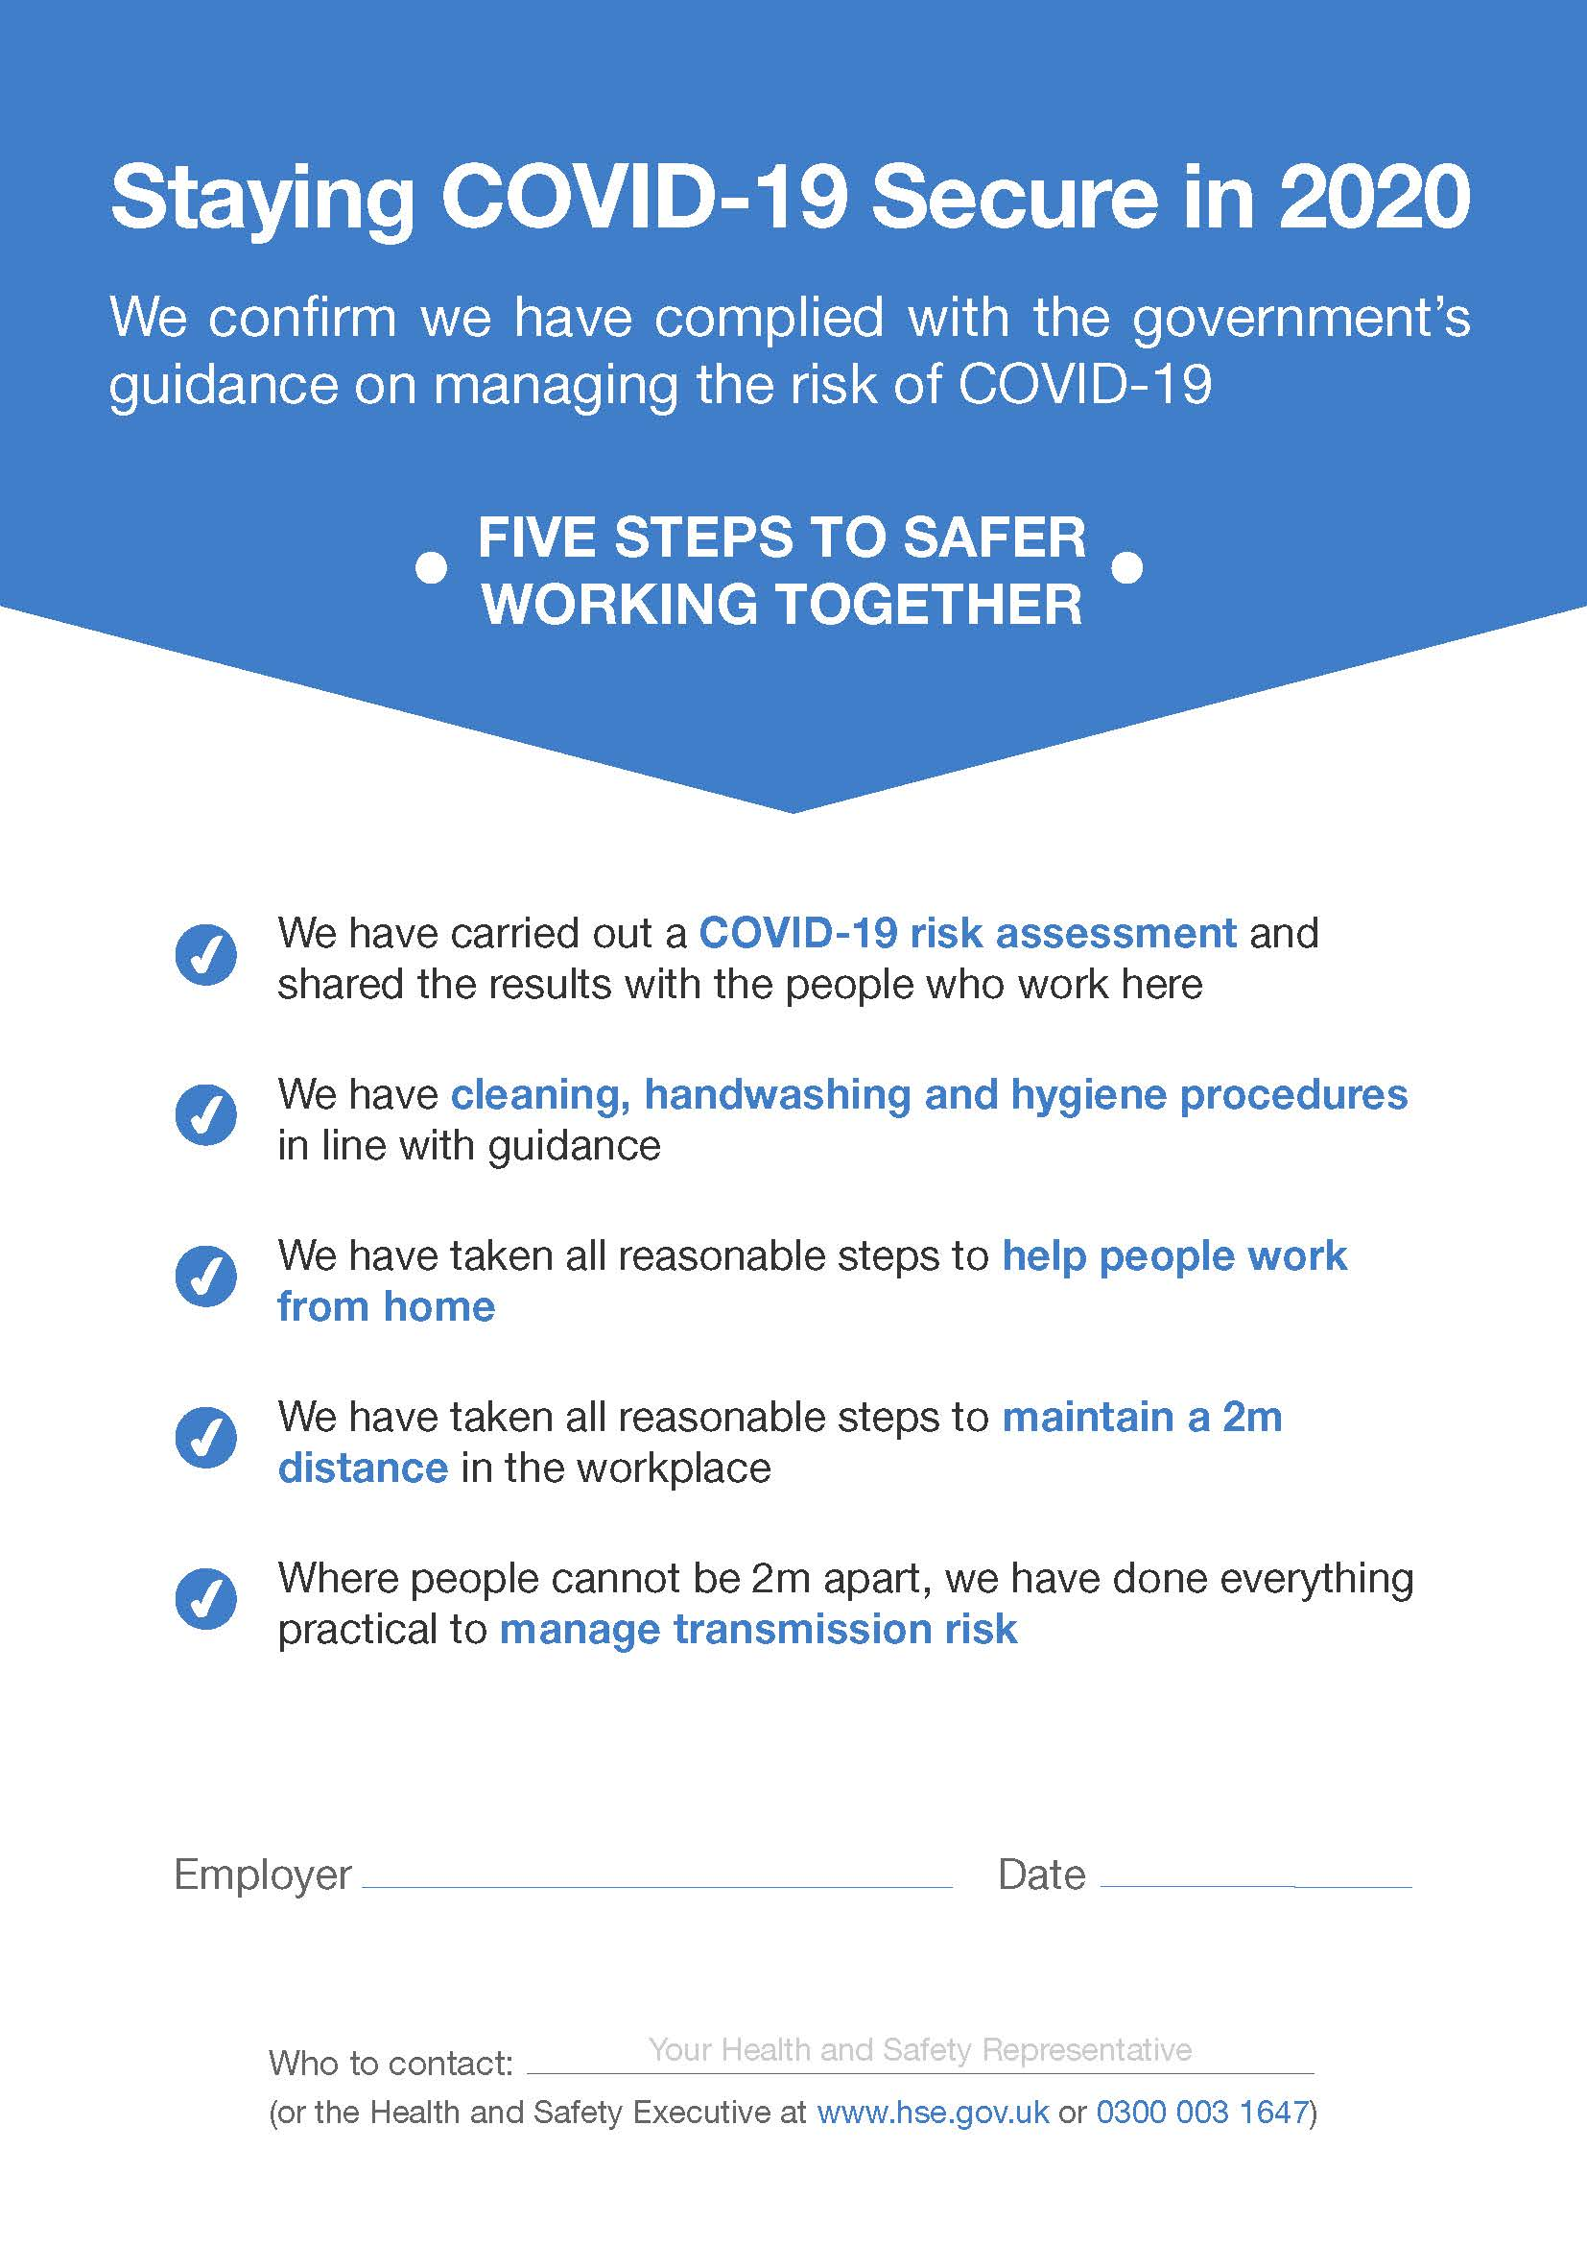

For further help and advice, please contact the Kent Film Office at filmoffice@kent.gov.uk or 03000 422000 during office hours.

